**MySQL Project**

**This is the result of the MySQL query for the sales data analysis project**

1. **Total Revenue**



1. **Year over Year Sales**

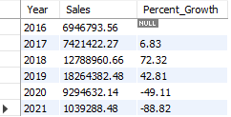

1. **Total Profit**



1. **Year over Year Profit**

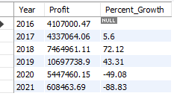

1. **Total Quantity**



1. **Year over Year Quantity**

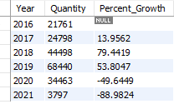

1. **Total Orders**



1. **Average Order Value**



1. **Average Product Per Order**



1. **Daily Trend For Total Revenue**

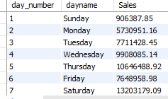

1. **Monthly Trend For Total Order**

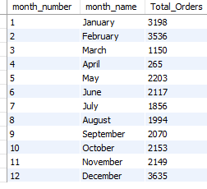

1. **Top 3 Category by Total Revenue in 2021**

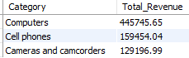

1. **Bottom 3 Category by Total Revenue in 2021**

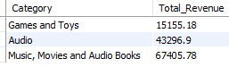

1. **Top 3 Category by Quantity Sold in 2021**

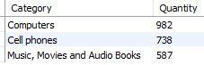

1. **Bottom 3 Category by Quantity Sold in 2021**

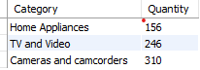

1. **Top 3 Category by Total Orders in 2021**

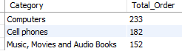

1. **Bottom 3 Category by Total Orders in 2021**

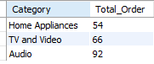

1. **Best sub-category by Total Revenue in 2020**



1. **Worst sub-category by Total Revenue in 2020**



1. **Which state has the highest sales rate in 2021**

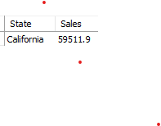

1. **Who are the customers with the highest shopping amount in 2021**

